EMBARGOED UNTIL 3:00 p.m., Pacific Time on Tuesday, 24 September, 2002
Canadian Environment Awards Gala: September 24, 2002
OTTAWA, Sept 24, 2002 - Canadian Geographic will host a gala evening to announce the winners of the Canadian Environment Awards 2002: A Celebration of Community Achievement. The event will take place on Tuesday, September 24, in the River Lobby of the Museum of Civilization in Hull, Quebec.
The Canadian Environment Awards 2002 is a new national program that recognizes 29 extraordinary nominees who are acting locally to help protect, preserve, and restore Canada's environment. The awards program was inspired by the community-action objectives of the Government of Canada's Environment Week. It recognizes a variety of grassroots endeavours on behalf of the environment in the areas of Clean Air; Clean Water; Climate Change; Environmental Health; Environmental Learning; Lands and Forests; Sustainable Living; and Wildlife and Nature. The nominees are leaders in their communities who are devoting their talents and energies to benefit our country.
__________________________________________________________________________________________
FOR BRITISH COLUMBIA MEDIA
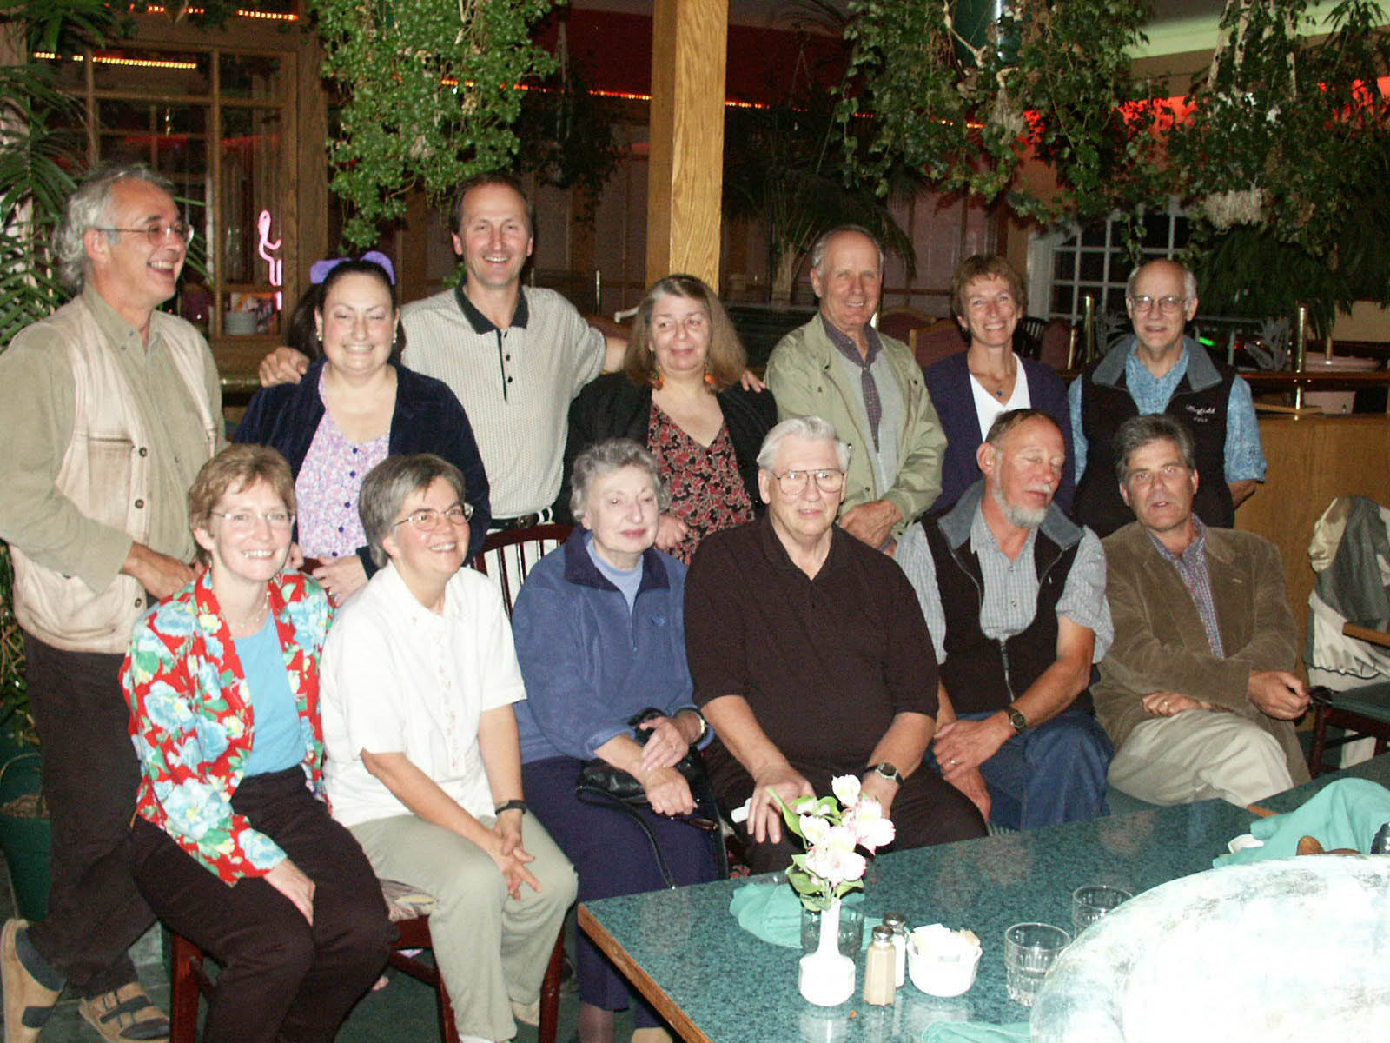
PORT ALBERNI, Sept. 24, 2002 - The Gold Award in the Clean Air category of the Canadian Environment Awards was won by the Citizens’ Stewardship Coalition (CSC) of Port Alberni, BC. Keith and Bernadette Wyton, of Port Alberni, were in Ottawa to receive the award on behalf of the CSC and the community members who fought the siting of a natural gas plant in town.
Citizens’ Stewardship Coalition members celebrating Canadian Environment Award in Clean Air category.
The coalition came together to express the concerns of people living in the Alberni Valley. BC Hydro wanted to locate an electricity-generating plant at the entrance to town and there was concern the emissions would disperse directly over the city. Citizens of Port Alberni said they had been negatively affected by poor air quality for half a century and were all too aware of what would happen if more, rather than less, air pollution happened here.
“No one asked us if we wanted the thing here,” said Keith Wyton. “No one asked the people, businesses, schools, or the community athletic centre, which are immediately adjacent or within .5 km of it if they wanted it there. No one told us about the socio-economic effects of this plant; particularly important as we are positioning ourselves for success in the growing tourism and ecotourism industries. Green energy projects are, on average, about four times more labour-intensive than what BC Hydro was proposing. If socio-economic benefits are to be achieved, then more jobs is better than fewer jobs.”
There was also concern about global issues, such as climate change. Coalition members said that by building in a need for natural gas, little effort would be made to develop green energy. Vancouver Island has excellent opportunities for green energy projects, including microhydro, wind, wave/tidal, geothermal, and solar.
In addition to these, there were general environmental issues, including water usage and effluent, the source of the water, etc. It turned out BC Hydro wanted to draw water from the Great Central–Sproat Lake system, which is important salmon habitat.
Nor was there, initially, sufficient recognition of impacts to aboriginal land claims, or to traditional uses on the affected areas. First Nations are a major component of Port Alberni society and have been actively engaged in compiling traditional use and ecological knowledge studies.
For more information, contact: For local information, contact:
Diane Chaperon-Lor Maggie Paquet, Secretary
Public Relations Manager Port Alberni Citizens’ Stewardship Coalition
Canadian Environment Awards Phone/Fax: 250-723-8802
Telephone: (416) 653-0849 email: maggie_paquet@telus.net
Cellphone: (416) 871-8882
email: chaperonlor@sympatico.ca
BACKGROUNDER: The Important Ingredients in our Success
The Citizens Stewardship Coalition is a broadly based group that came together specifically to respond to this issue. The group ran a petition campaign that garnered thousands of signatures, organised community meetings, started a newsletter and a letters-to-the-editor campaign, and held a demonstration at a city council meeting.
Hupacasath Chief Councillor Judith Sayers was an active member of the coalition who spoke eloquently at the hearings; her determination inspired all of us.
City council had to hold public hearings to rezone the property BC Hydro decided it wanted for the plant’s site. At these hearings, nurses, nurses, and more nurses spoke with great emotion and credibility on the health effects, particularly on children and the elderly, of particulate matter and bad air quality in general; and on what had happened in Port Alberni in past years, before the mill was “cleaned up” to the extent that it has been.
Our local cable TV station televised the rezoning hearings as they were happening. This inspired many hundreds of citizens to come down to the hearings and speak their minds—over 300 people stood up to speak against the rezoning and the proposed power plant, and hundreds more attended the hearings to give support by their sheer numbers.
“In nearly 30 years of being an involved citizen, I have never seen anything so inspiring or exciting. My faith in the people, in the potential of democracy, was lifted up and renewed. My cynicism for governments and corporations, unfortunately, was only strengthened,” said Maggie Paquet, a coalition member.
The rezoning hearings lasted over four nights and one day, and would have continued had not city councillors called an end, saying they would wait until the provincial environmental assessment process was completed. It was, plainly, a copout. The BC EA process had never denied an industrial project. City councillors wanted to pass the buck. A lot of people saw through that, but in our exhaustion, acceded.
The BC EA process began. There were no members of the public allowed on the committee, but First Nations were allowed on it, along with regional, provincial, and federal governments. The city declined to participate, saying it would be a conflict of interest since they were the owners of the property where the plant would be located. Here, Chief Judith Sayers was the lone committee member to continuously challenge BC Hydro and government on what turned out to be many inadequate statements and characterisations by BC Hydro of the potential environmental and socio-economic effects of the proposed plant. She tabled the lone dissenting statement and recommendations to the EA Office.
________________________________________________________________________________________
BACKGROUNDER ON CANADIAN ENVIRONMENT AWARDS
This year, the Canadian Environment Awards was a people's choice program, and the winners will be announced during the evening of September 24. The Honourable David Anderson, Minister of the Environment, is the keynote speaker. Gillian Deacon, broadcaster and television personality with the Discovery Channel, is the master of ceremonies. "This is an unprecedented opportunity to gather dedicated environmentalists from all regions of Canada," says Rick Boychuk, chair of the nominating panel and editor of Canadian Geographic. All nominees will be honoured with a commemorative plaque featuring the Natural Legacy Medallion produced by the Royal Canadian Mint.
The Canadian Environment Awards is produced and managed by Canadian Geographic in partnership with other community-minded organizations. "This gala is an opportunity to celebrate individual and community contributions to our country," says Paula Prociuk, program director of the Canadian Environment Awards. "The event will serve as a meeting place for environmentalists alongside leaders in the public and private sectors who support a sustainable future."
Program partners of the Canadian Environment Awards include the Government of Canada, Shell Canada, CHUM Radio Network and The Environmental Guides. Toyota Canada is a presenting sponsor; supporting sponsors include Panasonic, Quebecor, WestJet, VIA Rail, Royal Canadian Mint, and Bostonian Executive Suites.
_________________________________________________________________________________________
NOMINEES FOR THE CANADIAN ENVIRONMENT AWARDS 2002
CANDIDATS POUR LES PRIX DE LA PROTECTION DE L'ENVIRONNEMENT CANADIEN 2002
CLEAN AIR 2002/AIR PUR 2002
André Bélisle; Association québécoise de lutte contre la pollution atmosphérique
Citizens Stewardship Coalition; Port Alberni Community Group/Groupe communautaire de Port Alberni
Mary Griffiths; Energy Activist and Researcher/Militante et chercheuse dans le domaine l'énergie
Martha Kostuch; Environmental Activist/Militante en environnement
CLIMATE CHANGE 2002/CHANGEMENT CLIMATIQUE 2002
Climate Change Caravan; Climate Change Coalition/Coalition de lutte contre le changement climatique
David Coon; Conservation Council of New Brunswick/Conseil de la conservation du Nouveau-Brunswick
Jean Paradis; Founder and CEO/Fondateur et PDG, Négawatts
Ralph Torrie; Energy-Efficiency Consultant and Activist/Consultant et militant en efficacité énergétique
ENVIRONMENTAL HEALTH 2002/L'ENVIRONNEMENT ET VOTRE SANTÉ 2002
David V. Bates; Air-Quality Researcher/Chercheur en qualité de l'air
Nicole Bruinsma; Instrumental in pesticide ban in Chelsea, Quebec/Instigatrice de l'abolition des pesticides à Chelsea, au Québec
Donna Mergler; Research Scientist and Activist/Militante et chercheuse
Ann Marie Ross; Organizer/Organisatrice, Cape Breton Coke-Oven Action
ENVIRONMENTAL LEARNING 2002/APPRENTISSAGE ENVIRONNEMENTAL 2002
Rita Banach; Founder/Fondatrice, The Green Group
Monique Fitz-Back; Établissement vert Brundtland
Tim Grant . Gail Littlejohn; Publishers/Éditeurs, Green Teacher
Marcel Lafleur . Jean Robitaille; Creators/Créateurs, ERE Éducation
LANDS AND FORESTS 2002/TERRES ET FORÊTS 2002
John McCarthy; Ecologist and Forestry Activist/Écologiste et militant en foresterie
Allan Saganash Jr.; Forestry Activist and Policy-Maker/Stratège et militant en foresterie
Peter Schleifenbaum; Owner/Propriétaire, Haliburton Forest and Wild Life Reserve
Margo Sheppard; The Nature Trust of New Brunswick/La Fondation pour la protection des sites naturels du Nouveau-Brunswick
SUSTAINABLE LIVING 2002/DES MODES DE VIE DURABLES 2002
Federation of Canadian Municipalities/Fédération canadienne des municipalités; Leader in Environmental Initiatives/Promoteur d'initiatives environnementales
Save the Oak Ridges Moraine Coalition; Citizens' Conservation Group/Groupe de citoyens voué à la conservation
Wayne Roberts; Project Coordinator, Toronto Food Policy Council /Coordinateur de projets, Conseil de la politique alimentaire de Toronto
CLEAN WATER 2002/EAU PROPRE 2002
Clive Callaway . Sarah Kipp; The Living by Water Project/Le projet Living by Water
Roy Howard; Co-founder/Confondateur, Fraser Headwaters Alliance
Groupe de l'eau de la Covey Hill; Water Conservation Activists/Militants pour la conservation de l'eau
WILDLIFE AND NATURE 2002/FAUNE ET NATURE 2002
Alain Branchaud . Andrée Gendron; Aquatic Biologists and Environmental Entrepreneurs/Biologistes de la vie aquatique et entrepreneurs du secteur de l'environnement
David Loewen; Wild-Salmon Advocate/Militant pour la protection du saumon sauvage
The Petitcodiac Riverkeeper, Aquatic Restoration Group; Sentinelles Petitcodiac, Groupe de rétablissement du milieu aquatique

